SFTP User permissions:
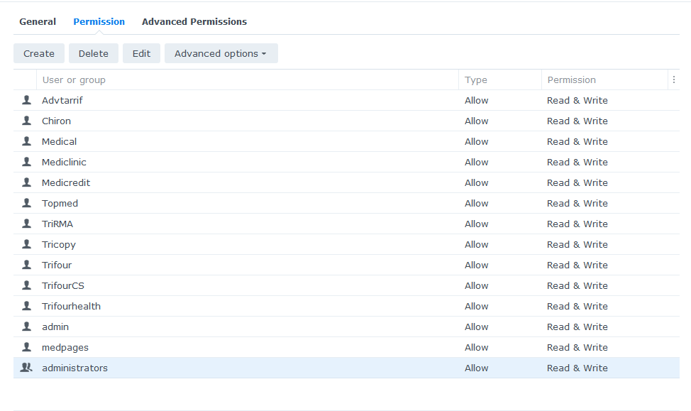
Permission per folder:
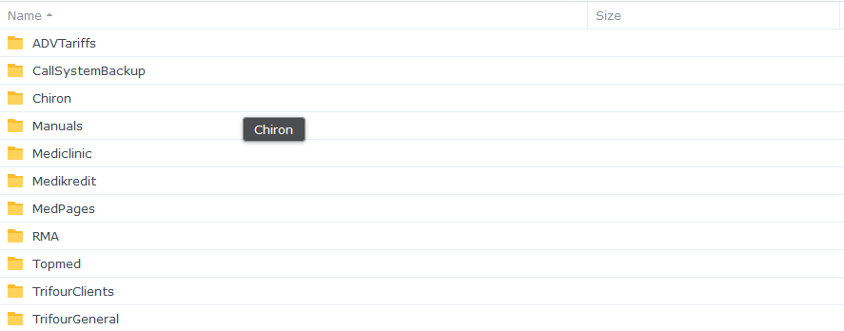
ADVTariffs:
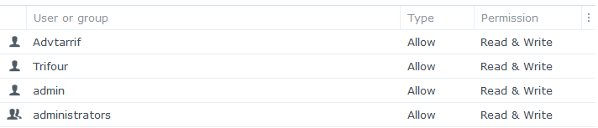
CallSytemBackup:
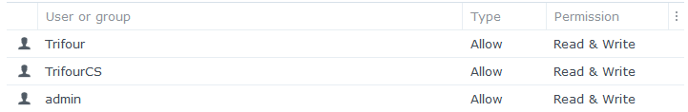

Chiron:
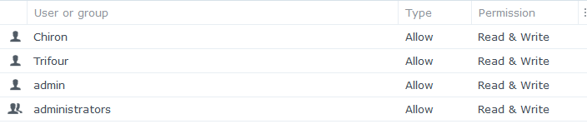

Manuals:
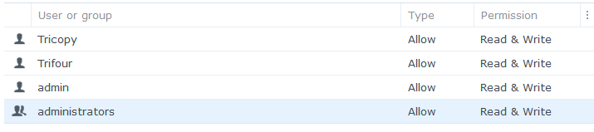

Mediclinic:
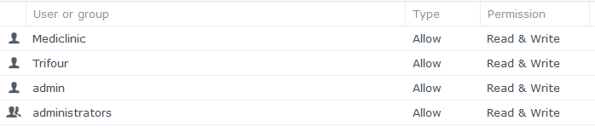

Medikredit:
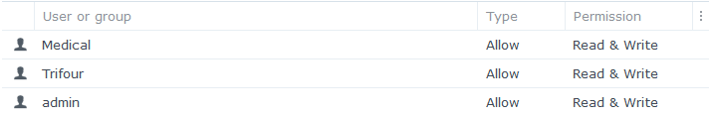

MedPages:
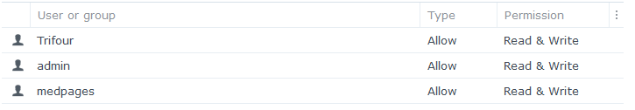

RMA:
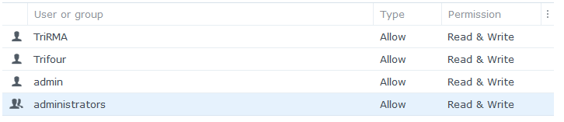

Topmed:
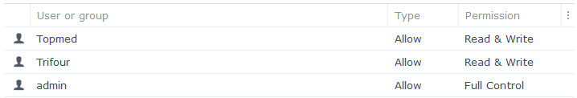

TrifourClients:
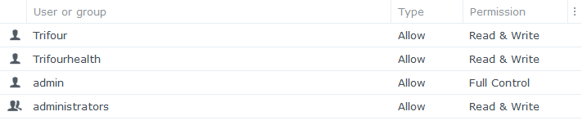

TrifourGeneral:
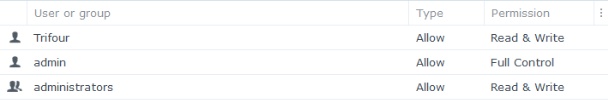

Password Policy:
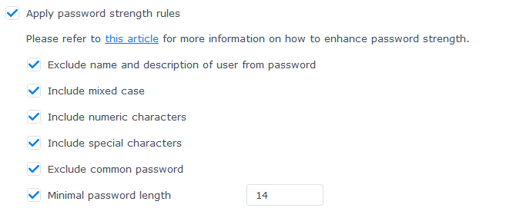

Storage usage:
